BYOC_HW6 Simulation 1:

Tsahi Barshevsky 311334544

Kostya Lokshin 310765821

A.1) Fill up the following table describing what happens in each CK cycle in all instructions. You should specify the specific operations that are required for the execution of the instruction.

We filled in the Rtype and j instructions – as examples. We also gave the list of required registers & signals to be mentioned in the table, in the ori instruction line.

|  |  |  |  |  |  |
| --- | --- | --- | --- | --- | --- |
| phase | **IF** | **ID** | **EX** | **MEM** | **WB** |
| Instruction |
| Rtype | IR=IMem[PC]  PC= PC+4 | A=GPR[Rs]  B=GPR[Rt]  Active signals:  RegDst=’1’  RegWrite=’1’  ALUOP=”10”  MemToReg=’0’ | ALUOUT = A op B  Rd is chosen:  Rd_pMEM=Rd_pEX | ALUOUT_pWB=  ALUOUT  (ALUOUT is delayed 1ck) | GPR[Rd_pWB]  = ALUOUT_pWB |
| addi | Need to tell what is loaded to IR & PC – the relevant regs. | Again, all regs that are relevant (A, B, sext_imm, PC in j & branch)  Also – all **active** signals created at the ID phase | All regs that are relevant (ALUOUT, B_reg_pMEM, Rd_pMEM, sext_imm) | All regs that are relevant (ALUOUT_reg_bWB, Rd_pWB, MDR)  MDR= DMem[adrs ] or  DMem[adrs]=B_reg_pMEM | GPR[Rd_pWB]  = ALUOUT_pWB |
| ori | Need to tell what is loaded to IR & PC – the relevant regs. | Again, all regs that are relevant (A, B, sext_imm, PC in j & branch)  Also – all **active** signals created at the ID phase | All regs that are relevant (ALUOUT, B_reg_pMEM, Rd_pMEM, sext_imm) | All regs that are relevant (ALUOUT_reg_bWB, Rd_pWB, MDR)  MDR= DMem[adrs ] or  DMem[adrs]=B_reg_pMEM | GPR[Rd_pWB]  = ALUOUT_pWB |
| lui | Need to tell what is loaded to IR & PC – the relevant regs. | Again, all regs that are relevant (A, B, sext_imm, PC in j & branch)  Also – all active signals created at the ID phase | All regs that are relevant (ALUOUT, B_reg_pMEM, Rd_pMEM, sext_imm) | All regs that are relevant (ALUOUT_reg_bWB, Rd_pWB, MDR)  MDR= DMem[adrs ] or  DMem[adrs]=B_reg_pMEM | GPR[Rd_pWB]  = ALUOUT_pWB |
| beq | IR=IMem[PC]  PC=PC+4 | PC= jump adrs  GPR_rd_data1_wt_fwd = ALUout_reg  Rs_equals_Rt = '1' | Nothing | nothing | Nothing |
| bne | IR=IMem[PC]  PC=PC+4 | PC= jump adrs  GPR_rd_data1_wt_fwd = ALUout_reg  Rs_equals_Rt = '1' | Nothing | nothing | Nothing |
| lw | IR=IMem[PC]  PC=PC+4 | ALUsrcB <= '1'  MemToReg <= '1'  RegWrite <= '1' | ALUsrcB_pEX <= ALUsrcB  Funct_pEX <= Funct;  ALUOP_pEX <= ALUOP  RegDst_pEX <= RegDst  RegWrite_pEX <= RegWrite  MemWrite_pEX <= MemWrite  MemToReg_pEX <= MemToReg | ALUout_reg <= ALU_output  RegWrite_pMEM <= RegWrite_pEX;  MemToReg_pMEM <= MemToReg_pEX;  MemWrite_pMEM <= MemWrite_pEX; | ALUout_reg_pWB <= ALUout_reg;  GPR_wr_data <= MDR_reg  RegWrite_pWB <= RegWrite_pMEM;  MemToReg_pWB <= MemToReg_pMEM; |
| sw | IR=IMem[PC]  PC=PC+4 | ALUsrcB <= '1'  MemWrite <= '1' | ALUsrcB_pEX <= ALUsrcB  Funct_pEX <= Funct;  ALUOP_pEX <= ALUOP  RegDst_pEX <= RegDst  RegWrite_pEX <= RegWrite  MemWrite_pEX <= MemWrite  MemToReg_pEX <= MemToReg | ALUout_reg <= ALU_output  RegWrite_pMEM <= RegWrite_pEX;  MemToReg_pMEM <= MemToReg_pEX;  MemWrite_pMEM <= MemWrite_pEX; | ALUout_reg_pWB <= ALUout_reg;  GPR_wr_data <= ALUout_reg_pWB  RegWrite_pWB <= RegWrite_pMEM;  MemToReg_pWB <= MemToReg_pMEM; |
| j | IR=IMem[PC]  PC=PC+4 | PC= jump adrs | Nothing | nothing | Nothing |
| jal | IR=IMem[PC]  PC=PC+4 | PC= jump adrs | JAL_pEX <= JAL | JAL_pMEM <= JAL_pEX | JAL_pWB <= JAL_pMEM |
| jr | IR=IMem[PC]  PC=PC+4 | PC= jump adrs  GPR_rd_data1_wt_fwd = ALUout_reg  jr_address = GPR_rd_data1_wt_fwd | Nothing | nothing | Nothing |

Answer the following questions.

A.2) Describe the changes done in order to support the ORI instruction.

**A2 – שינויים דרושים עבור הוספת ori:**

* להוספת הפקודות נדרשנו לשנות את הfetch unit של הפרוייקט וכן חלקים בtop כמובן.
* שינוי תנאי כניסה לsext imm לוודא שלא מדובר בפקודת ori כי אם כן אז sext_imm = imm ללא שינוי.

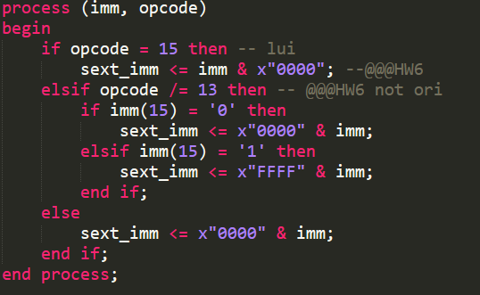

* הדלקת rewrite:



* הדלקת aluop ו-aluscrB:

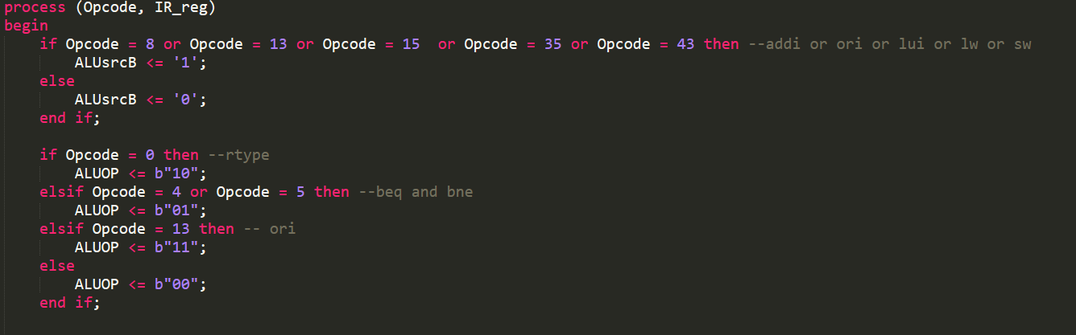

* שינויים בקובץ הalu לתמיכה בפקודה:

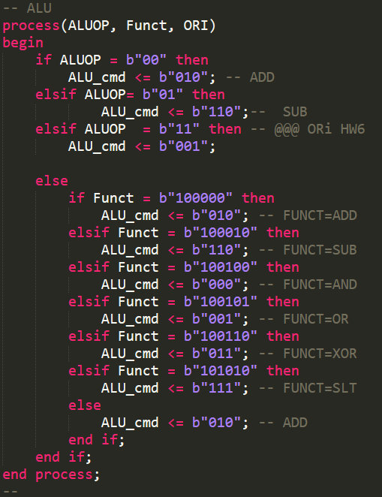

A.3) Describe the changes done in order to support the LUI instruction.

**A3 – שינויים דרושים עבור הוספת lui**

* שינוי ערך הsext imm כך שאם lui אז מבוצע באופן שונה. (קוד מופיע בהסבר של ori).
* איפוס הrs.

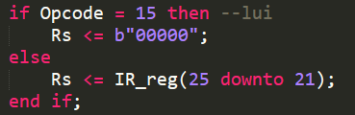

* הדלקת regwrite (קוד מופיע גם בori)
* הדלקת alusrcB (קוד מופיע גם בori)

A.4) Describe the changes done in order to support the JR instruction.

**A4 – שינויים דרושים עבור הוספת jr:**

* יצרנו משתנה חדש ככניסה לfetch unit בשם jr_adrs_in .

jr_adrs <= jr_adrs_in; --new input for part 6

* בtop משתנה זה מקבל את הערך שלו מgpr_read_data1.

A.5) Describe the changes done in order to support the JAL instruction.

**A5 – שינויים דרושים עבור הוספת jal**

* הpc register מקבל את הכתובת הרלוונטית לקפיצה.

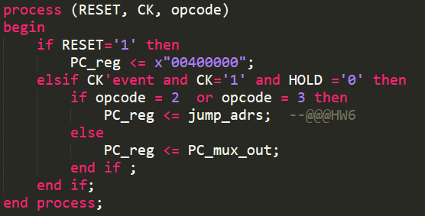

* העברנו החוצה מה fetch unit את pc +4 ו"שרשרנו" אותו ע"ב רגיסטרים לכל השלבים השונים.
* יצירת "דגל" בתכנית הראשית והדלקתו בopcode הרלוונטי
* "אילוץ rt " לערך 31 :

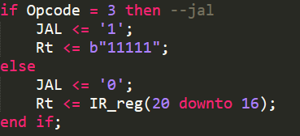

* הדלקת regwrite (קוד מופיע גם בori)
* שינוי הmux כך שיקבל את ה- pc + 4 המעודכן ויוציא את הערך הנכון:

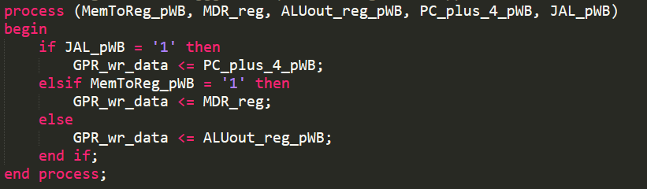

In your answers, besides stating the reasoning in detail, show the relevant VHDL code sections to better explain your answers.